**SECURITY SYSTEM FOR HOUSES**

**(BY USING AI)**

**Introduction:**

One of the most important foundations of life is to feel a degree of safety that is completely different from what is traditional now. In our time, after the spread of the various fields of artificial intelligence, which have swept all countries of the world and have become in constant development by programmers, we can take advantage of this world in how to create a safe and completely different environment. Imagine with me. Now, sir, you can see, hear, and modify everything about your home, whether you are inside or .outside, by just sending commands to the system in your home.

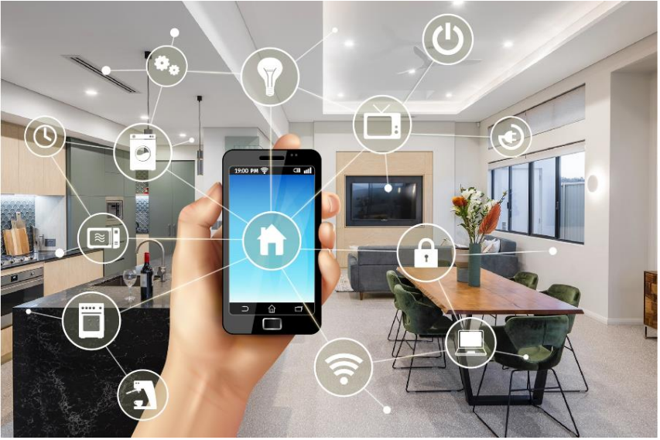

**First, let us understand the concept of artificial intelligence in terms of home security:**

Artificial intelligence, from a security perspective, refers to the application of AI technologies to enhance the security measures and capabilities of various systems and processes. It involves using AI algorithms and techniques to detect, prevent, and respond to security threats and vulnerabilities. This can include tasks such as anomaly detection, pattern recognition, and predictive analysis to identify potential risks and take proactive measures to mitigate them.

**What are the benefits and advantages of artificial intelligence in home security and safety?**

1. Enhanced Surveillance: AI-powered security systems can provide advanced surveillance capabilities, such as facial recognition, object detection, and behavior analysis. This enables more accurate and efficient monitoring of activities in and around the home, helping to identify potential threats or suspicious behavior.

2. Real-time Alerts and Notifications: AI algorithms can analyze data from various sensors and cameras to quickly detect and alert homeowners about potential security breaches or safety concerns. This allows for immediate action to be taken, such as notifying authorities or activating emergency protocols.

3. Smart Automation: AI can integrate with other smart home devices and systems, allowing for seamless automation of security processes. For example, AI can automatically lock doors, turn on/off lights, or adjust security settings based on predefined rules or user preferences.

4. Predictive Analysis: By analyzing historical data and patterns, AI can predict potential security risks or safety hazards. This proactive approach enables homeowners to take preventive measures and minimize the likelihood of incidents occurring.

5. Personalized Security: AI can learn and adapt to individual household routines and behaviors, creating personalized security profiles. This ensures that security measures are tailored to specific needs and preferences, providing a more efficient and effective home security solution.

6. Remote Monitoring and Control: With AI-powered mobile apps or platforms, homeowners can remotely monitor and control their security systems. This allows for real-time access to video feeds, alerts, and the ability to arm/disarm the system from anywhere, enhancing convenience and peace of mind.

**Does the degree of home security vary from person to person?**

One of the most important questions that must be answered in the beginning is the nature and life of the person who wants to place his home under the care and security of artificial intelligence, and the answer is yes, and it varies from one person to another according to the following:

1) The nature of the currency.

2) The amount of money spent.

3) The goal of protection.

4) Features included or added to its protection system.

And many other factors…

**Conclusion:**

In conclusion, artificial intelligence (AI) has significantly enhanced home security and safety measures. AI-powered systems can analyze and interpret data from various sensors, cameras, and devices to detect potential threats and take appropriate actions. These systems can identify unusual activities, such as unauthorized access or suspicious behavior, and alert homeowners or authorities in real-time.

AI algorithms can also learn and adapt to the homeowner's routines, distinguishing between normal activities and potential risks. This enables the system to provide personalized security solutions that cater to individual needs.

Furthermore, AI-powered surveillance cameras can provide advanced features like facial recognition, object detection, and tracking. These capabilities help in identifying intruders or suspicious objects more accurately, reducing false alarms and enhancing overall security.

Additionally, AI-based virtual assistants can control various smart home devices, allowing homeowners to remotely monitor and manage their security systems. This convenience provides peace of mind by enabling users to check on their homes' safety even when they are away.

However, it is important to consider potential privacy concerns associated with AI-powered home security systems. The collection and analysis of personal data raise questions about data protection and potential misuse. It is crucial for homeowners to choose reputable companies that prioritize privacy and adhere to strict data protection regulations